Week 7 Physics Lesson Notes.
ELECTRIC FIELD.
Electric lines of force
We know that, when a unit charge or point charge is placed in the electric field of another charged particle, it will experience a force.
The direction of this force can be represented by the imaginary lines. These imaginary lines are called electric lines of force. Electric lines of force are also called as electric field lines. The concept of electric lines of forces was introduced by Michael Faraday in 1837.
The direction of electric lines of force for positive and negative charge is shown in the below figure. For positive charge, the electric lines of force move away from the centre of the charge. But in case of negative charge, the electric lines of force move towards the centre of the charge.
The direction of electric lines of force for positive and negative charge is shown in the below figure.
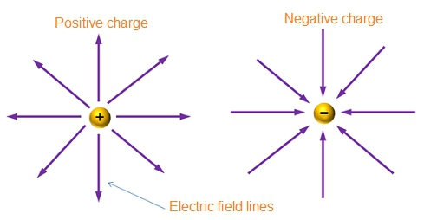
Opposite charges attract and like charges repel
Opposite charges attract
If two opposite charges are placed close to each other, they get attracted because the force present between them is attractive.
Let us consider two apposite charges as shown in below figure. Below figure clearly shows that for positive charge the electric lines of force moves away from the centre of positive charge and for negative charge the electric lines of force moves towards the centre of the negative charge.

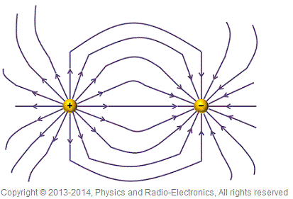
Like charges repel
If two positive charges are placed close to each other, they get repelled because the force present between them is repulsive.
Let us consider two positive charges as shown in below figure. Below figure clearly shows that for both the positive charges electric lines of force moves away from the centre of the positive charges.
If these two positive charges are placed close to each other, both the charges will try to move in the direction of electric lines of force. The positive charge at left side will try to move towards the positive charge at right side, but the electric lines of force of the right side positive charge oppose this movement. In the similar way, positive charge at right side will also experience a opposing force from left side positive charge. Hence, both the charges will experience a repulsive force from each other.
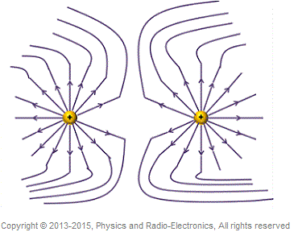
Properties of electric lines of force
1) The electric lines of force start from a positive charge and ends on a negative charge.
2) The electric lines of force always enter or leave the charged surface normally.
3) Electric lines of force can never intersect each other.
4) The electric lines of force cannot pass through a conductor.
5) When two opposite charges are placed close to each other, the electric lines of force present between them will become shorten in length.

Electric Current and Potential Difference
Electric Current
An electric current is the continuous flow of electrons in an electric circuit. As electrons carry a negative electric charge, this means an electric current is a flow of charge.
For an electric current to flow, we need:
1. A source to transfer energy to the electrons, for example, a battery (which provides the push that makes the charge flow)
2. A complete path for electrons to flow, an electrical circuit
When a circuit is complete, the charge will flow around the circuit.
We measure current using an ammeter
Current is measured in amperes, (also known as amps or A). The higher the charge, the bigger the current.
The circuit symbol for an ammeter is:
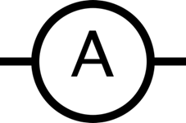
Connect the ammeter in series with the component you are measuring in a circuit.
Below you can see a diagram of a circuit with an ammeter and the same circuit using circuit symbols at the bottom. When placing an ammeter in a circuit, it must be placed in series with the circuit, so that the current you are measuring flows through the ammeter.
This includes the cell, the lamp, the switch and the wires connecting to the ammeter.
Let’s look at potential difference
Potential Difference
The potential difference (otherwise known as voltage) is the difference in energy between two components of a circuit. The higher the difference is, the higher the potential difference.
Remember, some people may call this ‘voltage‘ instead of ‘potential difference’
We measure potential difference using a voltmeter.

The units for potential difference is volts (or V)
Below is the circuit symbol for a voltmeter.
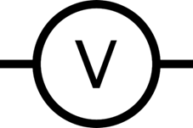
Connect the ammeter parallel with the component you are measuring in a circuit.
To measure the potential difference of a component, you connect a voltmeter with two wires and attach them to either side of the component you are measuring. In the diagram below, you can see what the circuit would look like if we wanted to measure the potential difference of the lamp.
On the top right is the voltmeter, with the symbol V.
If we wanted to measure the potential difference of the lamp above, we connect a wire to either side of the lamp and then to the voltmeter. If we put the voltmeter in the same loop as the component we are measuring, it will not work.
Production of Electric Current
Atoms are the basic building blocks of matter. Every object in the universe is made up of atoms. Atoms are the tiny particles. Their size is in nanometers.
Each atom consists of subatomic particles such as electrons, protons, and neutrons. These subatomic particles are smaller than the atom.
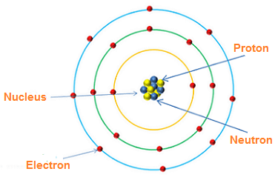
Electrons are the negatively charged particles, protons are the positively charged particles, and neutrons are the neutral particles (no charge).
Protons and neutrons are much heavier than electrons. So the protons and neutrons always reside at the center of the atom. The strong nuclear force between the protons and neutrons make them always stick together.
Protons have positive charge and neutrons have no charge. So the overall charge of the nucleus is positive.
Electrons always revolve around the nucleus because of the electrostatic force of attraction between them.
The electrons revolve around the nucleus in different orbits. Each orbit has an energy level associated with it.
The electrons revolving at a close distance from the nucleus have very low energy. On the other hand, the electrons revolving at a greater distance froverym the nucleus have high energy.
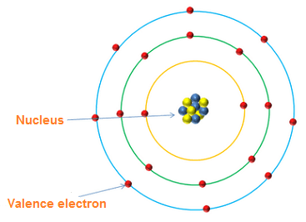
The electrons in the outermost orbit of an atom are called valence electrons. These electrons are very loosely attached to the parent atom. So applying a small amount of energy is enough to make them free from the parent atom.
When a small amount of energy in the form of heat, light, or electric field is supplied to the valence electrons, they gain sufficient energy and then separated from the parent atom.
The electrons that are separated from the parent atom are known as free electrons. These electrons move freely from one place to another place.
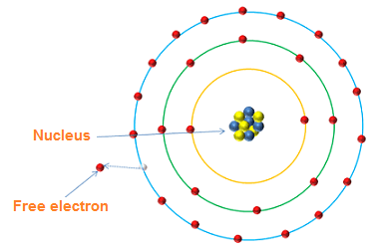
We know that electrons have a negative charge. So the free electrons carry negative charge from one place to another place.
We know that electric current means a flow of charge. So the electrons moving freely from one place to another place will conduct electric current.
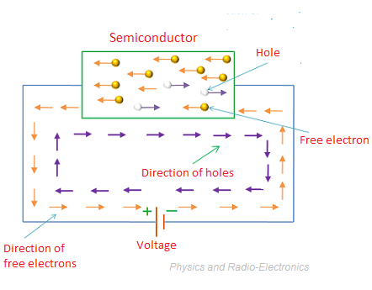
In semiconductors, both free electrons and holes are present. Free electrons are the negatively charged particles. So they carry a negative charge (electric current). Holes are the positively charged particles. So they carry a positive charge (electric current).
Thus, both free electrons and holes conduct electric current in semiconductors.
In conductors, holes are negligible. So the free electrons conduct electric current.
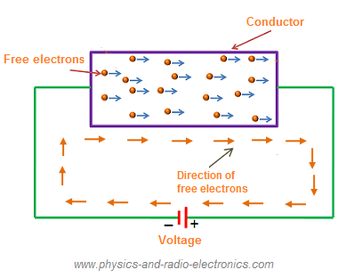
Protons also have the ability to conduct electric current. However, protons cannot move freely from one place to another place like electrons. They always held in a fixed position. So the protons do not conduct electric current.

WEEK 8 PHYSICS LESSON NOTE.
ELECTRIC CIRCUIT.
Definition of Electric Circuit : An electric circuit is the path provided for the flow of electric current. An electric circuit is a system that consists of the source of electricity, the key or switch and the connecting wires, ammeter to measure the current, voltmeter to measure the potential difference, Resistor or load and a rheostat to adjust the flow of current.

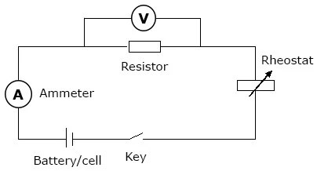
An ammeter must always be connected in a circuit in such a way that the current it measures flows directly through it. The ammeter is said to be connected in series in the circuit, in order not to alter the current it measures, the ammeter is constructed to have a low resistance.
The voltmeter which measures the potential difference between two points along a conductor must always be connected across or in parallel with these two points. The voltmeters are constructed to have a large electrical resistance compared to the resistance across the points they are connected.
Electric Conduction Through Materials: Ohm's Law
Ohm’s law states that the voltage across a conductor is directly proportional to the current flowing through it, provided all physical conditions and temperatures remain constant.
Mathematically, this current-voltage relationship is written as,
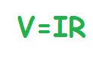
In the equation, the constant of proportionality, R, is called Resistance and has units of ohms, with the symbol Ω.
The same formula can be rewritten in order to calculate the current and resistance respectively as follows:
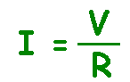
Ohm’s law only holds true if the provided temperature and the other physical factors remain constant. In certain components, increasing the current raises the temperature. An example of this is the filament of a light bulb, in which the temperature rises as the current is increased. In this case, Ohm’s law cannot be applied. The lightbulb filament violates Ohm’s Law.
Electric Work Done in a Given Circuit.
When charges move in an electric circuit, they carry some electrical energy associated with them. When they move from a region of higher to lower or lower to higher potential difference, work is done in the circuit. The rate of doing work can be measured by taking the amount of energy transferred and the time for which charges were in motion.
Formula used:
Power=work/time
Electric power is a form of mechanical power, and is defined as the rate of work done. It can also be expressed as the rate of consumption of electrical energy per unit time. Electric Power is described as the rate at which work is done or energy is transformed into an electrical circuit. It is a measurement of how much energy is used in a span of time.
Expression for Electrical Power in a circuit.
Power=worktime

Electrical energy is given by,
E=VQ
Therefore, P=VQ/t
Where, V is electric potential in volts
Q is electric charge in Coulombs
t is time in seconds
Electric power is essentially the rate, described per unit time, at which electrical energy or electricity is passed or transferred by an electric circuit. Power can be measured in different units. The SI unit for the measurement of power is Watt; 1 watt is equal to one joule per second.
NOTE: Examples during lessons

